# Introduction

Electronic Forms System (EFS) is the Office of Labor-Management Standards’ (OLMS) web-based reporting system for filing annual reports. The suggested changes in this document alleviate confusion with having to click the **Submit** button multiple times during a sequence of actions to print and then submit a final union report in EFS.

# Change Request Description

EFS Filers have reported having confusion with the print and submission functionality of EFS annual reporting. During a review of the EFS functionality, it was noted that use of the **Submit** button convoluted the steps to print and submit the final report (e.g., requiring the **Submit** button to be clicked three different times to in order to print, and eventually to get to submission of the final report). Filers often assumed that the final report was submitted after less than three different clicks when in fact it had not.

# Proposed Print Solution

The updated changes to EFS will provide additional notifications to Filers at the time two Union Officers have signed the report and Filer confirmation that print/download is or is not required prior to submission the final report. When a completed report has two signatures and is ready for submission, a Filer Notification Pop-up is presented to clearly determine if the Filer wants to download/print the completed report prior to submission, or proceed with the submission of the report without printing. (Note. If print/download is not executed at this step, the Filer can only view, print, or download the completed report after it has posted to Union Search).

# Changes to Achieve Print Solution

When the system captures the second signature successfully, Filer Notification Pop-up appears to the Filer stating that the report is ready to submit and recommends that the Filer print a copy of the report for their record. To proceed with any action in EFS, the Filer must click **Ok** to acknowledge having read the pop-up. The pop-up reads and looks as follows:

**Print a copy of this report NOW for your records before submitting**

**There is NO PRINT CAPABILITY via EFS once the report is submitted**

**Click the Print button above to print.**

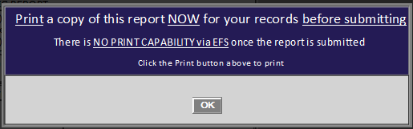

# Proposed Report Submission Solution

Once Filers have acknowledged the two-signature pop-up, the Filer can then print, download or submit the final report. Selecting **Print** prints the report for record (No change to this functionality). If the Filer chooses the **Submit** button, a download and submit pop-up appears.

The pop-up has two separate sections to clarify whether or not a Filer wants to download or to submit the final report. The top section of the pop-up displays a message to the Filer to download the report using the **Download** button. The pop-up reads and looks as follows:

“**Download a copy of this report NOW for your records before submitting**

**There is NO PRINT CAPABILITY via EFS once the report is submitted**

**Click Download and/or Submit to finish**.”

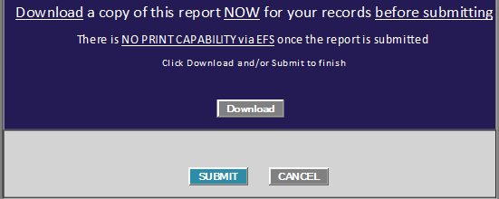

The bottom section of the pop-up displays the **Submit** and **Cancel** buttons to either continue with final submission of the report by clicking **Submit**, or cancel the submission by clicking **Cancel**. The separate **Download** and **Submit** buttons are independent of each other (i.e., Download is not required in order to submit the final report.) However, **Submit** or **Cancel** must be selected in order to close the pop-up. When **Submit** is selected, the report is officially submitted to the e.LORS database and a confirmation message is presented to the Filer. Printing or viewing the submitted report in EFS is no longer possible.

